**ISTANBUL TECHNICAL UNIVERSITY**

**COMPUTER ENGINERING DEPARTMENT**

**BLG 527E MACHINE LEARNING**

**CRN: 13817**

**Instructor: Zehra Çataltepe**

**Homework #2**

**November 6, 2017**

**Tuğrul Yatağan**

**504161551**

**Running Code**

q1.r and q2.r R files can be directly run. They search "optdigits.tra" and "optdigits.tes.txt" files in the same directory. If R files and data files are different directory, “trainingFile” and “testFile” variables must be set accordingly. It took about 30 minutes for q1.r and about 5 minutes for q2.r to run.

**Answers**

**Q1a-b)**

Steps for multivariate analysis:

1. Eliminate feature column in training data set if whole column is 0 or fixed value to be sure within-class scatter matrix is invertible.
2. Calculate d-dimensional mean vectors per class. Create meanij matrix.

$m_{i}=\left[\begin{aligned}μ_{w_{i}(feature 1)} \\ μ_{w_{i}\left(feature 2\right)} \\ . \\ μ_{w_{i}(feature 64)}\end{aligned}\right]$, with i = 0,1,2,3,...,9

1. Calculate common variance matrix

$$S=\sum_{i}{P(C_{i})S_{i}}$$

where covariance matrix $S_{ij}$

$$S_{ij}= \frac{\sum_{t=1}^{N}{(x_{i}^{t}-m_{i})(x_{j}^{t}-m_{j})}}{N}$$

1. Get diagonal elements of common variance matrix as vector s
   1. Use vector s as it is if common covariance matrix and Σ is diagonal
   2. Use square root mean of s if common covariance matrix) and Σ=s2I for some s>0
2. Discriminant function:
$$g_{i}\left(x\right)= - \frac{1}{2}\sum_{j=1}^{d}{{\left(\frac{x_{j}^{t}-m_{ij}}{s_{j}}\right)}^{2}+log⁡P(C_{i})}$$

3. Run discriminant function for dataset and get prediction results.
4. Create k X k confusion matrix.

**Q1c)**

1. Training error of Q1a:

8.579649 %

1. Test error of Q1a:

10.68447 %

1. Training error of Q1b:

8.16113 %

1. Test error of Q1b:

10.62883 %

1. Test error for each class for Q1a:

1.117, 22.413, 13.812, 5.389, 6.077, 5.494, 3.333, 7.978, 19.883, 21.134

1. Test error for each class for Q1b:

1.129, 22.285, 10.285, 5.263, 6.250, 7.065, 3.846, 8.602, 16.867, 23.414

1. Confusion matrix of the Q1a:

truth

prediction 0 1 2 3 4 5 6 7 8 9

0 177 0 1 0 0 0 1 0 0 0

1 0 135 6 0 4 0 5 0 21 3

2 0 21 156 2 0 0 0 0 1 1

3 0 0 0 158 0 1 0 0 1 7

4 1 0 1 0 170 1 0 3 0 5

5 0 1 0 3 0 172 0 0 2 4

6 0 4 0 0 0 1 174 0 1 0

7 0 0 1 7 3 0 0 173 1 3

8 0 8 10 6 3 0 1 2 137 4

9 0 13 2 7 1 7 0 1 10 153

1. Confusion matrix of the Q1b:

truth

prediction 0 1 2 3 4 5 6 7 8 9

0 175 0 1 0 0 0 1 0 0 0

1 0 136 6 0 8 0 3 0 19 3

2 0 16 157 1 0 0 0 0 1 0

3 0 1 2 162 0 0 0 0 1 5

4 2 0 0 0 165 1 0 3 0 5

5 1 1 0 2 0 171 0 2 3 4

6 0 5 0 0 0 1 175 0 1 0

7 0 0 2 7 3 0 0 170 1 3

8 0 7 5 5 4 0 2 2 138 3

9 0 16 4 6 1 9 0 2 10 157

Training data sets gives better error than test sets as expected. Q1b (Σi = Σ (common covariance matrix) and Σ=s2I for some s>0) assumption gives best test error.

Classes (1 & 2) and (1 & 8) have confused each other most.

**Q2a)**

1. Eliminate feature column in training data set if whole column is 0 or fixed value to be sure within-class scatter matrix is invertible.
2. Calculate d-dimensional mean vectors per class. Create meanij matrix.

$m_{i}=\left[\begin{aligned}μ_{w_{i}(feature 1)} \\ μ_{w_{i}\left(feature 2\right)} \\ . \\ μ_{w_{i}(feature 64)}\end{aligned}\right]$, with i = 0,1,2,3,...,9

1. Calculate scatter matrices
   1. Calculate within-class scatter matrix SW
   2. Calculate between-class scatter matrix SB
2. Solving the generalized eigenvalue problem for the matrix
$$S_{W}^{-1}S_{B}$$

3. Choosing 2 eigenvectors with the largest eigenvalues
4. Transforming the samples onto the new subspace for training and test data set by calculated eigenvectors from training data set.
$$Y=X ×W$$

5. Visualize training data set and test data set LDA results.
   1. Training data result:

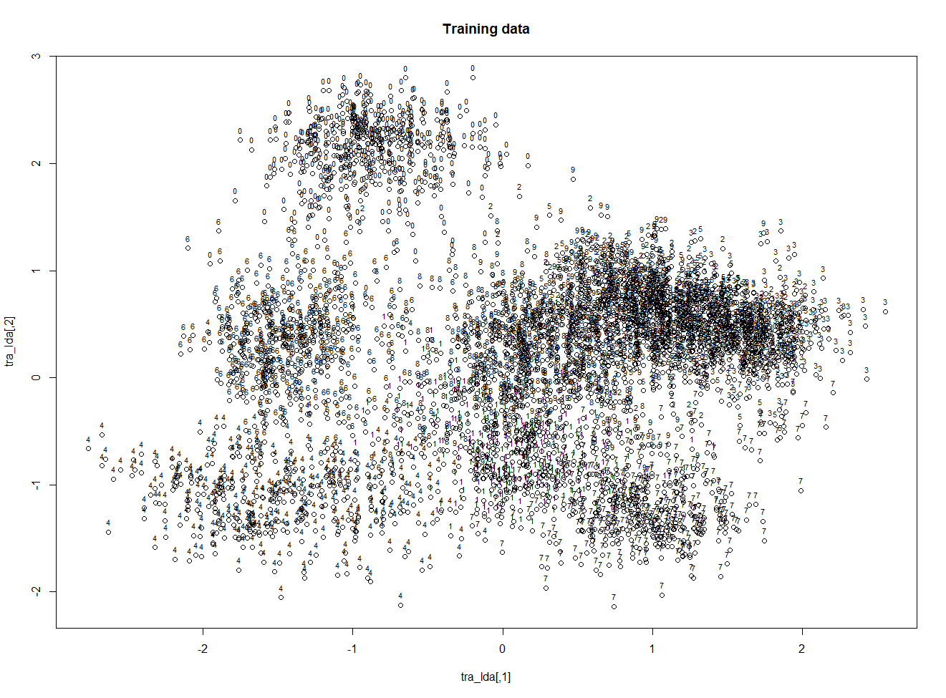

* 1. Test data result:

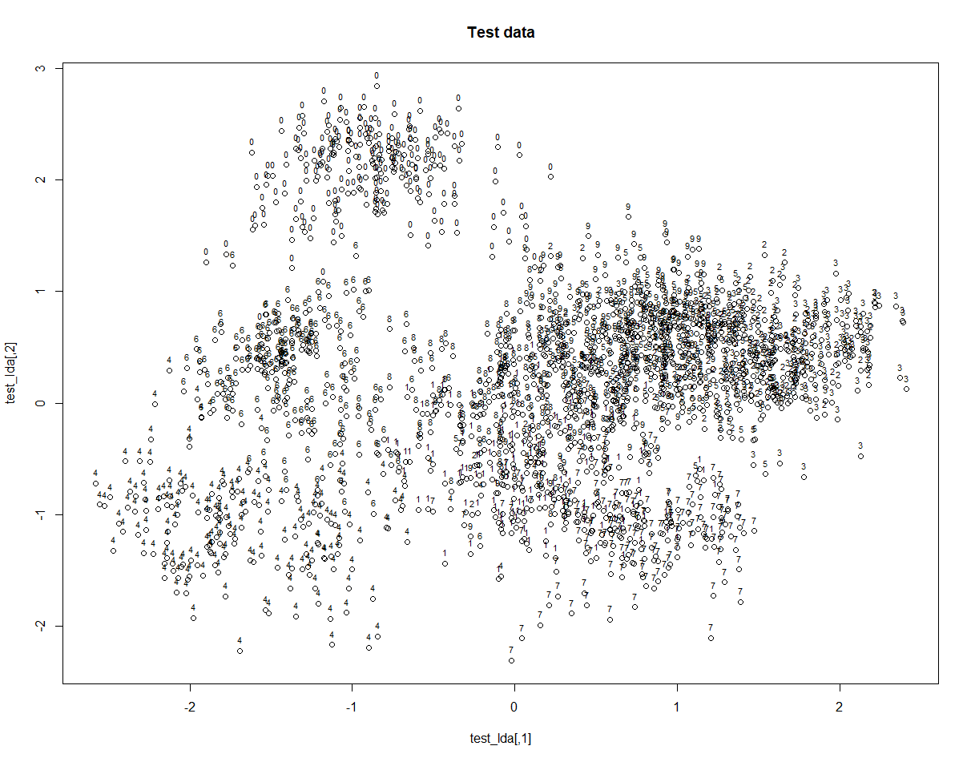

**Q3)**

LDA gives better for dimensionality reduction over PCA since, PCA doesn’t use class information to reduce dimension.

We are interested in the matrix W that maximizes:

$$J\left(W\right)= \frac{\left|W^{T}S_{B}W\right|}{\left|W^{T}S_{W}W\right|}$$

The largest eigenvectors $S_{W}^{-1}S_{B}$ is the solution, and PCA within-class scatter matrix SW gives bigger value over LDA which leads to worse dimension reduction.